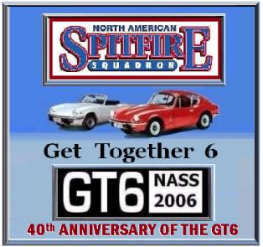

Eastern Get-Together 2006

Celebrate the GT6 at 40

Carlisle, PA May 19-21, 2006

Carlisle Import-Kit/Replicar Nationals

Carlisle Fairgrounds

Registration Form

Name: ___________________________ E-mail: ____________________ Phone: ________________
Address: __________________________ City: ___________________St/Prv ________Zip ________

Participate in NASS events & car show - $25/car (price includes t-shirt, dash plaque & lapel pin) T-shirt size M__ L__ XL__ XXL__
Additional T-shirt $10/ea T-shirt size M__ L__ XL__ XXL__ (Please indicate quantity)

NASS Get-Together “Show within a Show” Car Classes
A. Round Tail: 1962-1970, MKI, MKII, MKIII  B. Late Square Tail: 1971-1977 MKIV and Early 1500  C. Late Square Tail: 1978 and Later 1500  D. All GT6s | E. Spitfire/GT6 Daily Driver  F. Spitfire/GT6 Diamond in the Rough  G. British & Other Cars
A. (Registration/First Car $25) Car year________ Make/Model________________ Class (see above)________
B. (Registration/Addl. Car $10) Car year________ Make/Model________________ Class (see above)________
C. (Registration/Addl. Car $10) Car year________ Make/Model________________ Class (see above)________

Whereas owner(s) voluntarily enters his/her vehicle in the 2006 Eastern NASS Get-Together, it is agreed as follows: (1) That owner(s) will insure his/her vehicle against loss, damage, and liability and will provide proof of such insurance being in full force and effect to the 2006 NASS Get-Together Committee, Carlisle Productions and motel, as needed; (2) That owner(s) does hereby agree to indemnify and hold harmless the NASS Get-Together Committee, agents, or assigns for any act or omissions which may result in the act, damage or destruction or injury occurring during or as a consequence of this event, wherever located; (3) The owner(s) in attending this event does so voluntarily and agrees and assumes the risk of any and all damage to his/her vehicle or injury to him/her self. Please sign below.
Owner: ________________________________  Co-Owner:______________________________ | Date:___________  Date:___________
Total Submitted: $ _______________
Please mail Registration Form and Fee by May 3, 2006, after May 3rd, register/pay at location. Please remit completed form and a check or money order payable to NASS to: NASS EGT-2006
c/o Rohan de Silva,
530 Burton Avenue
Hasbrouck Heights, NJ 07604-2325
email: desilvarc@yahoo.com

