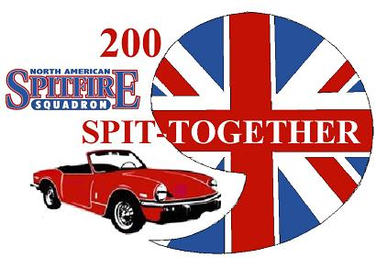
REGISTRATION FOR THE NASS 2009 SOUTHERN SPIT-TOGETHER MAY 1-3

The MITTY registration must be submitted separately. Go to www.themitty.com.

Name___________________________________

Address_________________________________
CLASSES For NASS Show Within a Show:

A: Round Tail 1962-1970, MKI, MKII, MKIII
B: Square Tail 1971-1980, MKIV, & 1500
C: All GT-6s
D: Daily Driver
E: Diamond In The Rough
F: Farthest Travelled
G: Officer’s Choice

City____________________________________

State ___________________________________

Phone ________________ Cell______________

Email ___________________________________

Host Hotel: Days Inn in Gainesville, GA For $75.00/ night. (Group code PGNORT or North American Spitfire Squadron). 770-535-8100. The rooms are blocked off at that rate until April 1.

Registrations received by April 1st will receive 1 Dash Plaque, 1 T-Shirt and 1 Hat Pin per car, while supplies last. Select the size for your T-Shirt: S___M___L___XL___XXL___

Car # 1: Year_________Make_____________Model___________Class (above) ____ $25 $______
Car # 2: Year_________Make_____________Model___________Class (above) ____ $10 $______

Total for Registration $_________

Friday Dinner: How Many ____ Saturday Dinner: How Many ____ (self pay at restaurant)

Sunday optional Breakfast at hotel: (self pay at restaurant)

Sunday drive to Dahlonega through the North Georgia Mountains: Joining us: Yes __ No ___
Afternoon stop at Consolidated Gold Mine tour the mine and do some gold panning: Yes __ No ___
Gold panning is $13.00/person (self pay at the mine)

Additional Event T-Shirt(s) How Many______@ $10.00 each ………………………………… $______
Size: S___M___L___XL___XXL___ (must know before April 1, 2009)
Total Due: $______

Make Checks payable to NASS and Mail to:
NASS SST 2009 c/o Alan Hughes, 3130 Ball Ground Rd., Ball Ground, GA 30107.

Whereas owner(s) voluntarily enters his/her vehicle in the 2009 Southern Regional Spit Together, it is agreed as follows(1)owner(s)will insure vehicle against loss, damage, and liability and will provide(if requested)proof of such insurance being in full force and effect to the 2009 NASS SST Committee. (2)Owner(s) does hereby agree to indemnify and hold harmless the 2009 NASS SST Committee, agents, or assigns for any act or omissions, which may result in the act, damage, or destruction or injury occurring during or as a consequence of this event, wherever located. (3) The owner(s) in attending this event does so voluntarily and agrees and assumes the risk of any and all damage to his/her vehicle or injury to him/her self

Owner_____________________________ Co-Owner_________________________

Date: _________________________________

