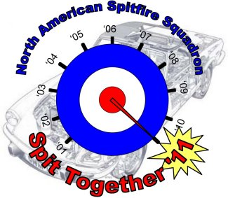

Participate in NASS events & car show
– FREE 1st car
price are t-shirts and includes t-shirt, dash plaque, lapel pin
NASS Spit-Together “Show within a Show” Car Classes
- Round Tail: 1962-1970, MKI, MKII, MKIII
- Late Square Tail: 1971-1977 MKIV and Early 1500
- Late Square Tail: 1978 and Later 1500
- All GT6s
- Spitfire/GT6 Daily Driver
- Spitfire/GT6 Diamond in the Rough
- British & Other Cars
(Registration/1st Car Free)
Car #1 Class (see above)________
Car year________ Make/Model________________
(Registration/2nd Car $15)
Car #2 Class (see above)________
Car year________ Make/Model________________
Note:
Class flexibility will be allowed the day of the show
First T-shirt size included in S-I-A-S registration
Select size M___ L___ XL____ XXL____
Additional T-shirt $10/ea
(Please indicate quantity)_____
Select size M___ L___ XL____ XXL____

Planning to attend the Saturday night BBQ:
YES________ NO________

DON’T Forget to Register with
Carlisle for the Fun Field itself http://www.carsatcarlisle.com/import/index.asp

Registrant Identity

______________________________________
Name:
______________________________________
Street address:

______________________________________
City: State Zip code

___________________ ________________ phone: membership #

_______________________________________ email address:

Whereas owner(s) voluntarily enters his/her vehicle in the 2011 Eastern NASS Spit-Together, it is agreed as follows: (1) That owner(s) will insure his/her vehicle against loss, damage, and liability and will provide proof of such insurance being in full force and effect to the 2011 NASS Spit-Together Committee, Carlisle Productions and motel, as needed; (2) That owner(s) does hereby agree to indemnify and hold harmless the NASS Spit-Together Committee, agents, or assigns for any act or omissions which may result in the act, damage or destruction or injury occurring during or as a consequence of this event, wherever located; (3) The owner(s) in attending this event does so voluntarily and agrees and assumes the risk of any and all damage to his/her vehicle or injury to him/her self. Please sign below.
Owner:

Co-owner:
Please email Registration Form to Jim Holmgren by May 13th, Any funds due can be paid on the show field.
If paying by check Please remit completed form and a check or money order payable to NASS to:
NASS EGT-2011
c/o Jim Holmgren
505 Palomino Dr
York, PA 17402
( Ph 443.506.2400)
email: jholmgren@gmail.com

This registration is for the NASS events only

